TripAdvisor E-Management

SalesForce

## Hardware Required:

System with advance configuration **Software** Required:

Salesforce Platform **System Required:** Effective

Configuration:

The TripAdvisor E-Management app with the salesforce works with your

all-in-one travel companion, empowering you to plan, book, and make the most of the trips. Discover millions of reviews and insights shared by fellow travelers, helping you make informed decisions for every aspect of your journey. Whether you're seeking the perfect hotel, top-rated restaurants, must-visit attractions, or the best travel deals, TripAdvisor has you covered

## Submitted by

au713621104017au713621104025 au713621104033

1. **Create Object**

Hotel Object is created to ensure that when a new Food Option is added or updated with the necessary information.

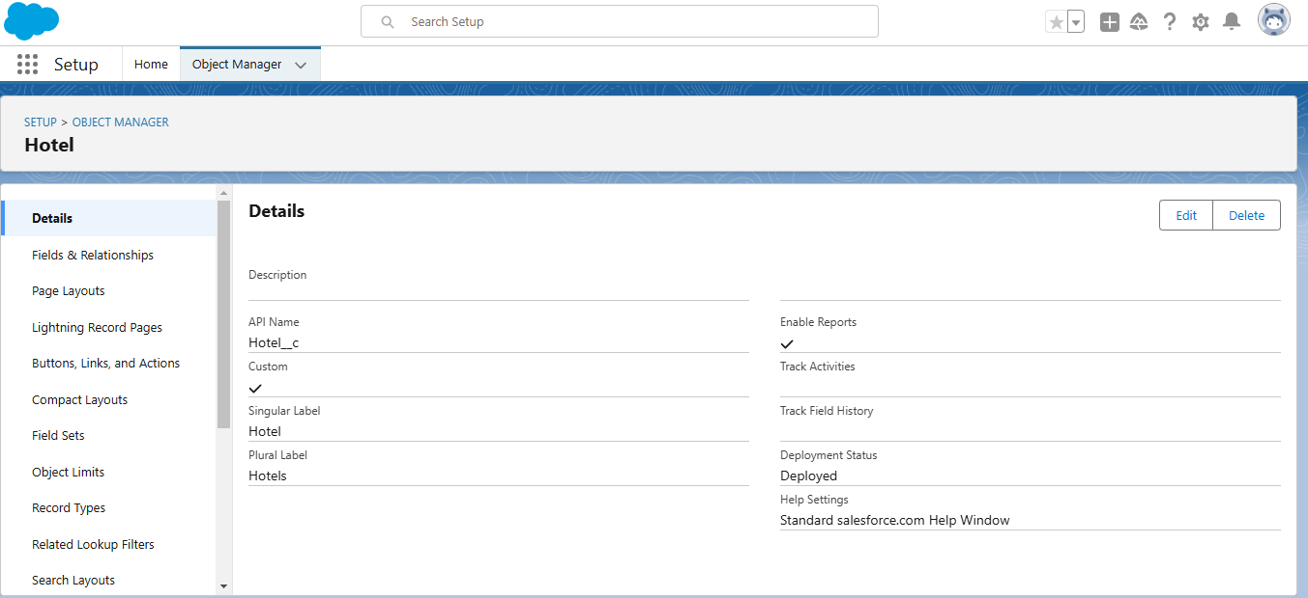

# Create Fields for Hotel Object

|  |  |  |
| --- | --- | --- |
| Sr. No. | Field Name | Data Type |
| 1 | TotalFoodOptions | Number |
| 2 | Date | Date |

1. 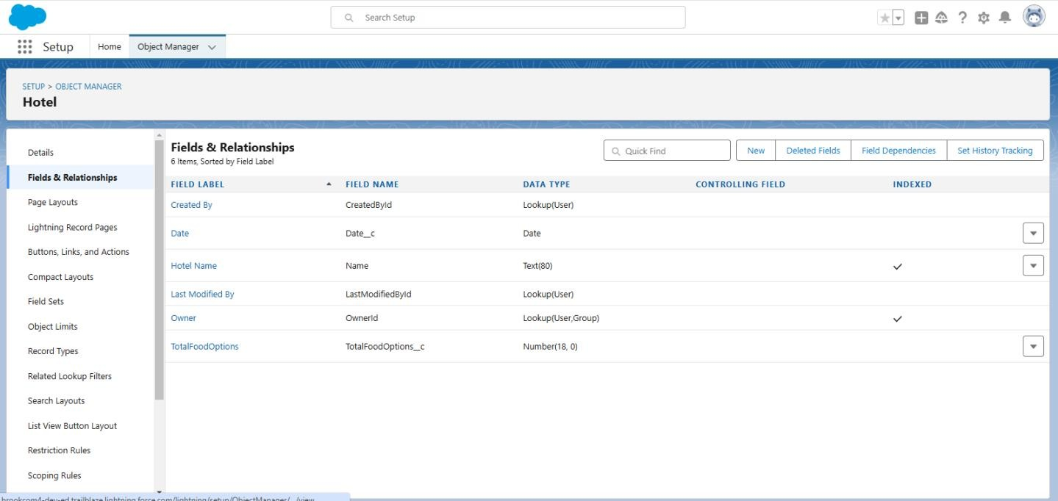**Create Fields for Food Option**

|  |  |  |
| --- | --- | --- |
| **Sr. No.** | **Field Name** | **Data Type** |
| 1 | Name | Text |
| 2 | Hotel | Hotel(Lookup) |
| 3 |  |  |
| Food Amount | Currency |

# Create Fields in the Flight Object

|  |  |  |
| --- | --- | --- |
| **Sr. No.** | **Field Name** | **Data Type** |
| 1 | Name | Date/Time |
| 2 | DepartureDateTime | Hotel(Lookup) |

1. 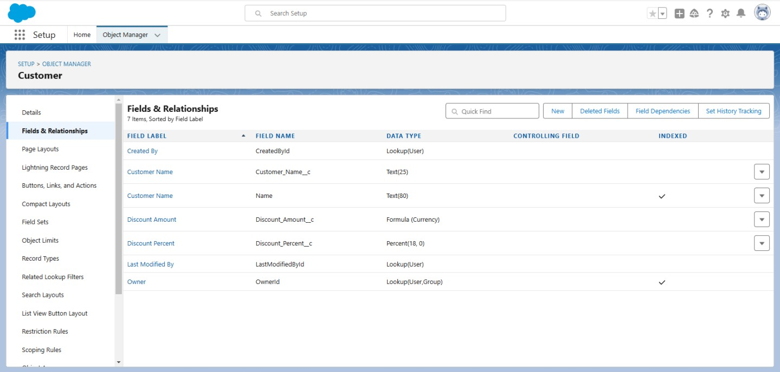**Create Fields in the Customer Object**

|  |  |  |
| --- | --- | --- |
| **Sr. No.** | **Field Name** | **Data Type** |
| 1 | Customer Name | Name |
| 2 | Discount Amount | Formula (Currency) |
| 3 | Discount Percent | Percentage |

# Create Flow

Create the Flow for the discount for customer when the Amount is greater than 3000 some Amount of Discounts will be there if the Amount is between 1500 to 3000 so Some Amount of Discount will be there for them.

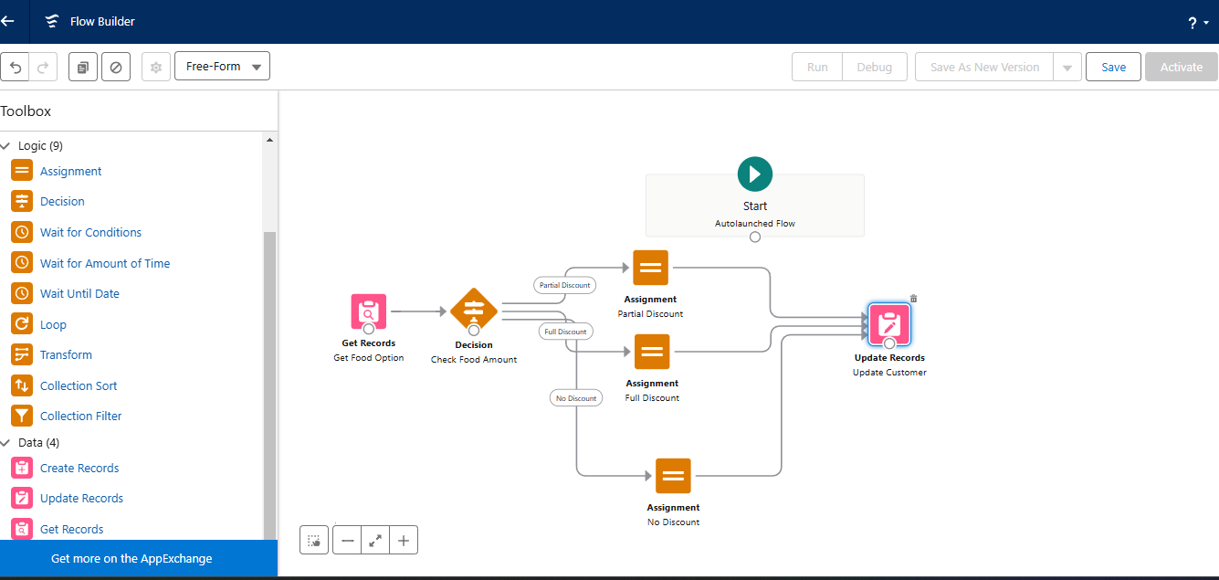

# Apex Triggers

Scenario: In the Hotel you have to ensure that when a new Food Option is added or updated, the corresponding Hotel's information is updated accordingly. For example, you might want to maintain a total count of food options for each hotel. To manage the things properly with perspective to the Hotel things should be clearly manageable for making the food options available with respect to hotels.

**Program:**

**public class FlightReminderScheduledJob implements Schedulable {**

**public void execute(SchedulableContext sc) {**

**sendFlightReminders();**

**}**

**private void sendFlightReminders() {**

**// Query for flights departing within the next 24 hours**

**List<Flight__c> upcomingFlights = [SELECT Id, Name, DepartureDateTime__c FROM Flight__c**

**WHERE DepartureDateTime__c >= :DateTime.now()**

**AND DepartureDateTime__c <= :DateTime.now().addDays(1)];**

**for (Flight__c flight : upcomingFlights) {**

**// Customize the logic to send reminder emails**

**// For this example, we'll print a log message; replace this with your email sending logic.**

**System.debug('Sending reminder email for Flight ' + flight.Name + ' to ' + flight.ContactEmail__c);**

**// Example: Send email using Messaging.SingleEmailMessage**

**Messaging.SingleEmailMessage email = new Messaging.SingleEmailMessage();**

**email.setToAddresses(new List<String>{ flight.ContactEmail__c });**

**email.setSubject('Flight Reminder: ' + flight.Name);**

**email.setPlainTextBody('This is a reminder for your upcoming flight ' + flight.Name +**

**' departing on ' + flight.DepartureDateTime__c);**

**Messaging.sendEmail(new List<Messaging.SingleEmailMessage>{ email });**

**}**

**}**

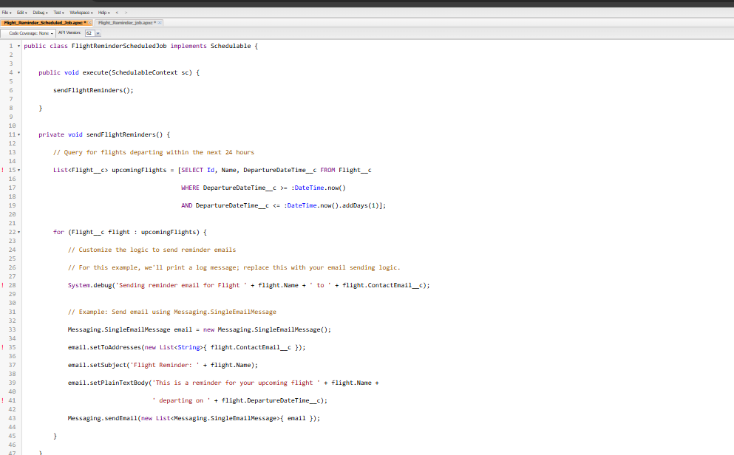

**Apex Trigger:(code)**

### Apex Trigger With Handler

### 2.Trigger

### trigger FoodOptionTrigger on Food_Option__c (after insert, after update, after delete) {

### If(trigger.isInsert && trigger.isAfter){

### FoodOptionTriggerHandler.updateHotelInformation(trigger.new);

### }

### }

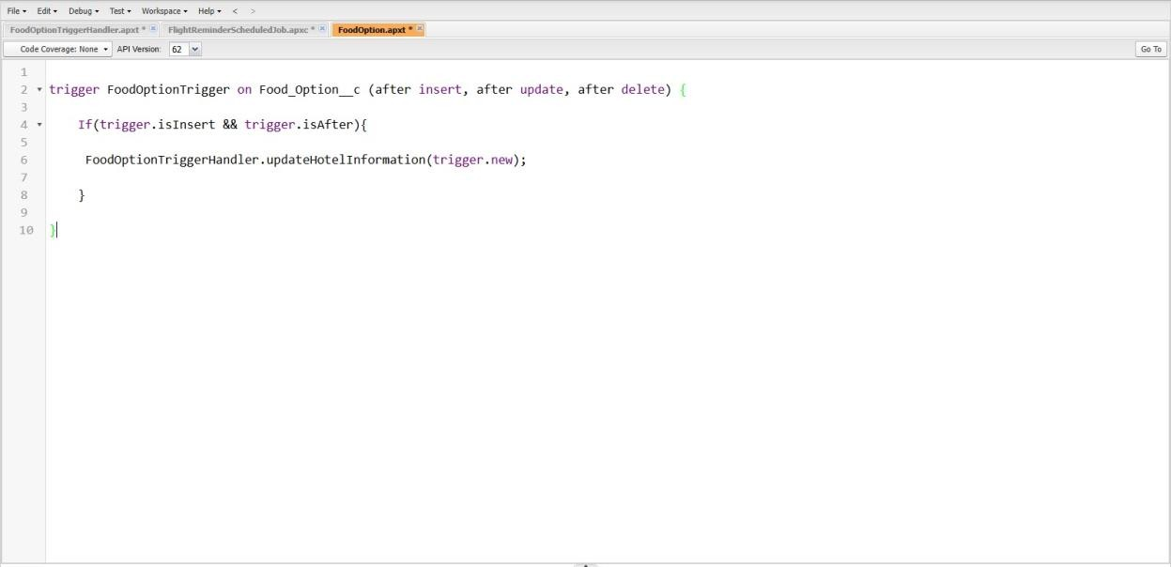

# 8.Apex Schedule

Create the Reminder mail for the customer who has booked the flight according to that booking set the Apex schedule so mail will be sent prior to 24hrs. Note: Please create the required field for Scheduled Apex Code

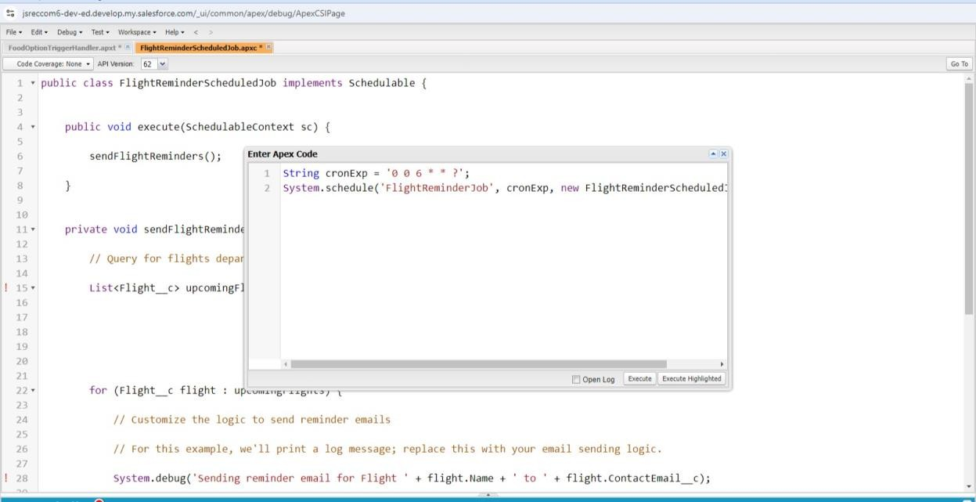

# Apex Schedule Class Solution

public class FlightReminderScheduledJob implements Schedulable { public void execute(SchedulableContext sc) { sendFlightReminders();

}

private void sendFlightReminders() {

List<Flight c> upcomingFlights = [SELECT Id, Name, DepartureDateTime c FROM Flight c

WHERE DepartureDateTime__c >= :DateTime.now() AND DepartureDateTime c <=

:DateTime.now().addDays(1)];

for (Flight__c flight : upcomingFlights) { System.debug('Sending reminder email for Flight ' +

flight.Name + ' to ' + flight.ContactEmail c); Messaging.SingleEmailMessage email = new Messaging.SingleEmailMessage(); email.setToAddresses(new List<String>{ flight.ContactEmail c

}); email.setSubject('Flight Reminder: ' + flight.Name);

email.setPlainTextBody('This is a reminder for your upcoming flight ' + flight.Name +

' departing on ' +

flight.DepartureDateTime c);

Messaging.sendEmail(new List<Messaging.SingleEmailMessage>{ email }); }

}

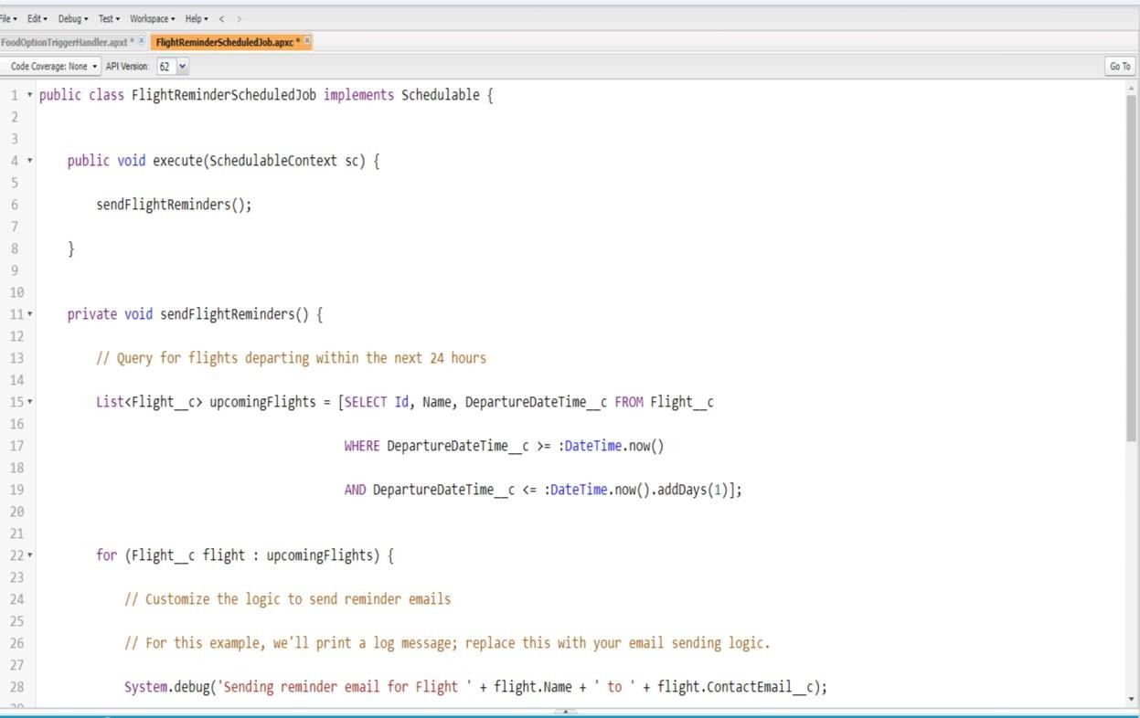

}

### DASHBOARD

